Appendix A
Details on Linking Methods
Fixed-Parameter Calibration (summed VR-12 scores). Item responses in both linking samples (PROMIS GPH + VR-12 PCS, PROMIS GMH + VR-12 MCS) were calibrated in a single run with PROMIS parameters fixed at their previously published values.¹ Thus, the item parameters of the VR-12 items were estimated, subject to the metric defined by the PROMIS item parameters and yielded item parameters for the VR-12 on the PROMIS metric.
Equipercentile Linking (algorithmic VR-12 scores). For each VR-12 component (MCS and PCS), we created an equipercentile link based on the VR-12’s published scoring algorithm. We rounded each participant’s VR-12 MCS and PCS scores to the nearest integer value. Once we had pairs of scores for the VR-12 components and PROMIS Global Health scales, we calculated each score’s percentile rank within the sample. The scores of the two measures were then aligned by associating scores with equivalent percentile ranks on the two score distributions. The equipercentile linking was conducted using the LEGS program.² By applying the LEGS cubic-spline smoothing algorithm,³ the impact of random sampling error was minimized.^{2, 4, 5} Because sum score equivalents may take fractional values, cross-walk tables were also interpolated using statistical procedures (e.g., cubic spline ²). For comparison, we allied three levels of post-smoothing: 0.0 (no smoothing), 0.3 (some smoothing), and 1.0 (large smoothing).²

Appendix B
Unidimensionality Analysis and Details on Classical Item Statistics
Method
Confirmatory factor analyses (CFA) were conducted on the raw data treating the indicator variables as ordinal and using the WLSMV estimator of Mplus.⁶ This model posited that all items load on a single factor. We also estimated the proportion of total variance attributable to a general factor (OmegaH) ^{7, 8} as well as the explained common variance (ECV) index using the psych package ⁹ in R.¹⁰ This method estimates OmegaH from the general factor loadings derived from an exploratory factor analysis and a Schmid–Leiman transformation.¹¹ Values of 0.70 and 0.60 or higher for OmegaH and explained common variance (ECV), respectively, are tentative benchmarks suggesting unidimensionality of the item set.^{12, 13}
Results
Results from classical item statistics suggested reasonable levels of internal consistency and homogeneity for combined item sets (see Table B1). Cronbach’s internal consistency reliability coefficients were high, ranging from 0.83 to 0.89. Item responses in each of the combined datasets also were highly inter-correlated, with average inter-item correlations ranging from 0.42 to 0.51. Estimates of general factor saturation (OmegaH) were relatively high: 0.74 and 0.74 (PROMIS GMH and MCS), 0.74 and 0.79 (PROMIS GPH and PCS). ECV values ranged from 0.66 to 0.74 for the combined sets. These values suggest the presence of a dominant general factor for each instrument pair.¹³
The CFA statistics, on the other hand, suggested lack of fit to a unidimensional model, which is not surprising given the variation in content across instruments. PROMIS GMH and VR-12 MCS (10 items) fit values were: CFI = 0.844, TLI = 0.799, and RMSEA = 0.213. PROMIS GPH and VR-12 PCS (9 items) fit values were CFI = 0.888, TLI = 0.860, and RMSEA = 0.190. While these statistics did not meet commonly used fit criteria, there is considerable debate over the appropriate cut-off values and the strict adherence to these indices to assess model fit.^{14, 15} Fit indices are sensitive to skewed distributions, the number of items,¹⁶ and item wording.¹⁷ In the context of IRT analysis of psychological measures, it is important to note that item sets need to be relatively unidimensional, ideally considering the preponderance of evidence emerging from a range of statistical indices.^{16, 18} Furthermore, simulations comparing fit statistics directly to factor-strength indices such as OmegaH suggest the latter may be better suited to assess whether a set of items are “unidimensional enough.”¹³

Table B1
Reliability Estimates and Item Analysis for Individual and Combined Instruments
 | Items | Item-Total Correlations* |  |  | AIIC | Standardized Alpha | OmegaH | ECV
Instruments |  | Min. | Mean | Max.
PROMIS Mental Health | 4 | 0.48 | 0.63 | 0.70 | 0.52 | 0.81 | 0.79 | 0.82
VR-12 MCS (Sum) | 6 | 0.44 | 0.57 | 0.69 | 0.42 | 0.80 | 0.72 | 0.63
PROMIS GMH & VR12 MCS (Sum) | 10 | 0.44 | 0.60 | 0.68 | 0.42 | 0.87 | 0.74 | 0.66
PROMIS GMH & VR12 MCS (Algorithm) | 5 | 0.50 | 0.58 | 0.63 | 0.51 | 0.84 | 0.74 | 0.74
PROMIS Physical Health | 4 | 0.55 | 0.58 | 0.60 | 0.47 | 0.78 | 0.74 | 0.84
VR-12 PCS (Sum) | 7 | 0.49 | 0.59 | 0.68 | 0.44 | 0.83 | 0.72 | 0.63
PROMIS GPH & VR12 PCS (Sum) | 11 | 0.54 | 0.63 | 0.70 | 0.44 | 0.89 | 0.77 | 0.66
PROMIS GPH & VR12 PCS (Algorithm) | 5 | 0.47 | 0.60 | 0.70 | 0.49 | 0.83 | 0.74 | 0.69

* Item-total correlations are corrected for item overlap.
AIIC = Average Inter-Item Correlation; ECV = explained common variance; GMH = Global Mental Health; MCS = Mental Component Score; PCS = Physical Component Score; GPH = Global Physical Health; VR-12 = Veteran’s RAND 12-item Health Survey

Appendix C
Evaluation of Linking Accuracy
Method
We used a single-group design, the strongest of available linking designs.^{19, 20} In this approach, items from each instrument are administered to all participants and scores are obtained for each respondent on each measure to be linked. This is convenient when evaluating the validity of the linking method, because actual scores on the anchor or reference measure (PROMIS Global scores in the current study) are obtained, as well as those generated by linking through the target measures (VR-12)
We evaluated the accuracy of linking by comparing (estimated) linked scores to their actual scores. We computed Pearson product-moment correlations between estimated and actual scores, and calculated the mean and standard deviation of the differences in scores. Our expectation was that magnitude of these correlations would be close to those of the original and that the mean of the differences would be close to zero.
Users of the cross-walk tables may wish to know that the size of their samples affect the error associated with linking. To estimate how this error decreases as sample size increases, we conducted a resampling procedure to obtain multiple, random, small subsets of cases (n = 25, 50, 75, 100, 125, 150, 175, and 200). Samples were drawn randomly with replacement over 10,000 replications (bootstrapping). For each replication, the mean difference between the actual and linked PROMIS T-score was computed. This resulted in a distribution of differences that might be expected with different sample sizes. The means and the standard deviations of these distributions were computed over replications as an estimate of bias and empirical standard error, respectively.
Results
To evaluate the accuracy of our linking, we compared the actual PROMIS Global Health T-scores to those estimated by linking. We computed the correlations, mean differences, and standard deviations (SD) of difference scores for the linked and actual scores (see Table C1). Correlation and SD of differences indicated that the physical components based on the summed VR-12 items provided the strongest link. The physical components based on the algorithmic VR-12 item scores provided the weakest link. This weakness, however, can be greatly mitigated if users of the cross-walk table convert scores of moderate-sized samples and calculate the mean of these converted scores.
Table C2 estimates how sample size (i.e. the number of scores) equated with the cross-walk tables is related to accuracy. As sample size increased from 25 to 200, the empirical standard error decreased. These standard errors can be used to create confidence intervals around linking results. For example, when the cross-walk table is used to estimate PROMIS GPH from a sample of 150 VR-12 PCS sum scores, there is an estimated 95% probability that the difference between the mean of the linked PROMIS scores and the mean of the actual PROMIS T-scores (if obtained) would be within ± 1.0 T-score units (i.e., 1.96 x the 0.49 standard error). For the same sample size (N=150) and using the algorithm-based equipercentile link to VR-12 PCS scores, the 95% confidence interval is 1.2 T-score units. Though larger than for the more accurate IRT-based method, this level of error may be acceptable for many research purposes, particularly in light of the probability that differences less than 0.2 SD are not likely to be meaningful in most applications.^{21, 22}
Table C1
Correlations, Mean Differences, and Standard Deviations of Differences between Actual vs. Linked PROMIS Global Health T-Scores
 |  |  | Correlation | Mean of Differences | SD of Differences
PROMIS GPH & VR-12 PCS
 | Sums |  | 0.80 | -0.29 | 5.90
 | Algorithm |  | 0.68 | -0.09 | 7.44
PROMIS GMH & VR-12 MCS
 | Sums |  | 0.66 | -0.26 | 7.53
 | Algorithm |  | 0.60 | 0.12 | 8.14
GMH = Global Mental Health; MCS = Mental Component Score; PCS = Physical Component Score; GPH = Global Physical Health; VR-12 = Veteran’s RAND 12-item Health Survey

Table C2
Standard Deviation of Differences between Linked and Actual Mean PROMIS Global Health Scores, by Sample Size used in Resampling Procedure
 | N =25 | N = 50 | N =75 | N = 100 | N = 125 | N = 150 | N = 175 | N = 200
PROMIS Global Physical Health
Cross-Walk Chart (Sums) | 1.17 | 0.82 | 0.67 | 0.58 | 0.50 | 0.47 | 0.42 | 0.40
Cross-Walk Chart (Algorithm) | 1.48 | 1.03 | 0.84 | 0.72 | 0.65 | 0.57 | 0.54 | 0.50
PROMIS Global Mental Health
Cross-Walk Chart (Sums) | 1.48 | 1.04 | 0.85 | 0.73 | 0.65 | 0.60 | 0.54 | 0.50
Cross-Walk Chart (Algorithm) | 1.60 | 1.13 | 0.93 | 0.80 | 0.70 | 0.64 | 0.59 | 0.54

Appendix D
Subpopulation Invariance
Following the recommendation of Dorans and Holland,²³ we tested a third linking assumption (subgroup invariance) by computing the Standardized Root Mean Square Deviation (RMSD). The RMSD estimates the standardized difference of subpopulations (e.g., men and women) across two instruments. In all samples, we evaluated invariance for sex and age (65 and over / less than 65).
Results
We calculated RMSD values for sex-related and age-related differences on the mental and physical scales, using both summed and algorithmic calculations of VR-12 (eight comparisons in all) to evaluate whether RMSD values were within the 8% range suggested by Dorans and Holland ²³ for useful linkages. That is, 8% or less of the variance by demographic group could be explained by instrument differences. All but one RMSD value was within this range. The lone exception was the age-related differences based on algorithmic scores for the VR-12 PCS (RMSD = 10.1%). The RMSD for this comparison based on summed scores was within the 8% range. We judged this violation to be relatively minor and elected to proceed with this link as well as with the others. Our logic was that some users will have no choice but to link with VR-12 algorithmic scores (if summed item scores are unavailable). Further, our analytic plan allows us to further evaluate this link based on actual results (i.e., differences between linked scores and actual scores).

Appendix E
Supporting Figures and Tables

Figure E1
Raw score distribution for PROMIS Global Mental Health Scale.

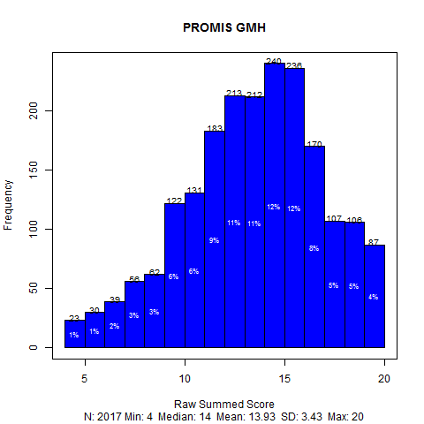

Figure E2
Raw score distribution for VR-12 Mental Health Component. VR-12 = Veteran’s RAND 12-item Health Survey

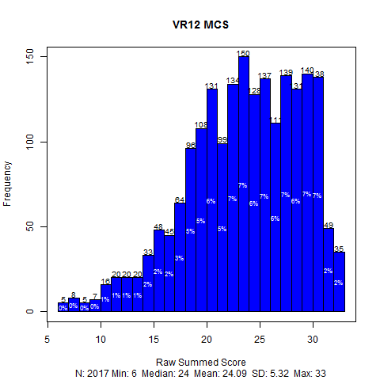

Figure E3
Scale information functions for the mental health items of the VR-12 (6 items) and PROMIS Global Mental Health (4 items). VR-12 = Veteran’s RAND 12-item Health Survey

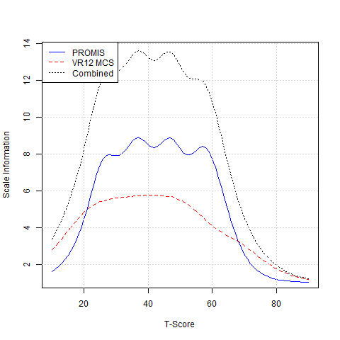

Figure E4
Raw score distribution for PROMIS Global Physical Health.

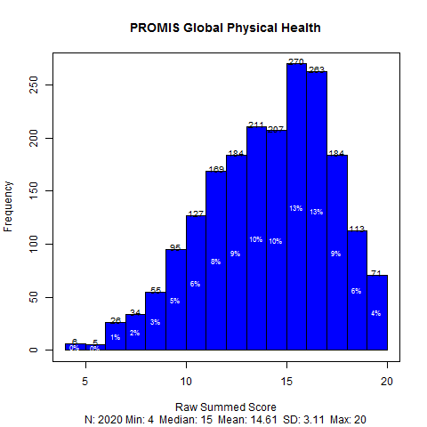

Figure E5
Raw score distribution for VR-12 Physical Health Component. VR-12 = Veteran’s RAND 12-item Health Survey

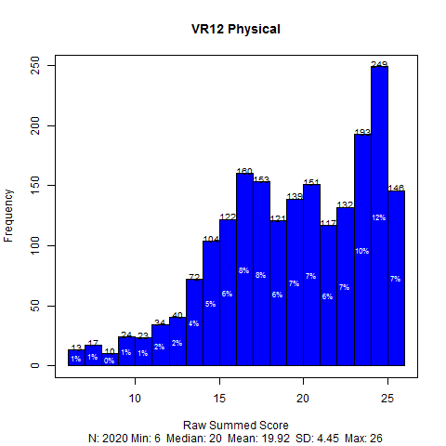

Figure E6
Scale information functions for the physical health items of the VR-12 (7 items) and PROMIS Global (4 items). VR-12 = Veteran’s RAND 12-item Health Survey

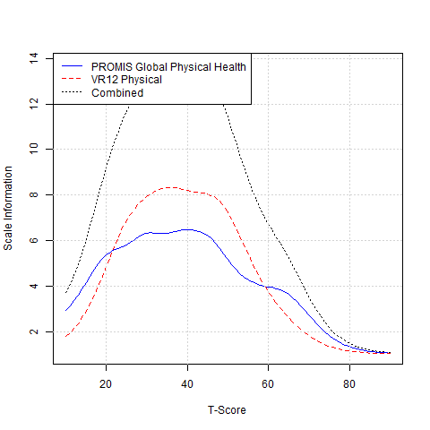

Figure E7
Linking relationship between VR-12 and PROMIS Global Health scores for mental and physical components. VR-12 = Veteran’s RAND 12-item Health Survey

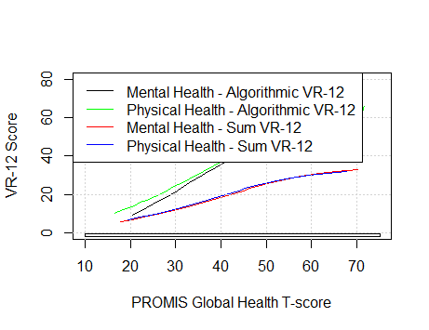

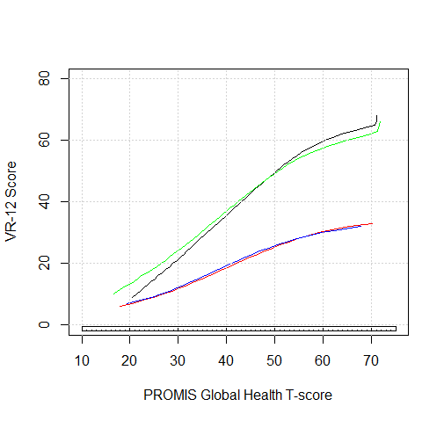

Table E1
Correlations between the VR-12 and PROMIS Global scale scores prior to linking
Pair of Scales to be Linked | Pearson | Pearson (disattenuated)* | Spearman
PROMIS GMH & VR12 MCS (Sum) | 0.69 | 0.86 | 0.65
PROMIS GMH & VR12 MCS (Algorithm) | 0.63 | 0.70 | 0.60
PROMIS GPH & VR12 PCS (Sum) | 0.80 | 0.99 | 0.80
PROMIS GPH & VR12 PCS (Algorithm) | 0.69 | 0.79 | 0.70
*Disattenuated correlations are divided by the square root of the product of the reliability coefficients (Cronbach’s alpha) of the two measures.
Table E2
Transformed Item Parameter Estimates (Fixed-Parameter Calibration) for the VR-12
Item | a | cb1 | cb2 | cb3 | cb4 | cb5
 |  | Mental Health Component
Energy (6b) | 1.78 | -2.33 | -1.23 | -0.33 | 0.39 | 1.85
Peaceful (6a) | 1.73 | -2.85 | -1.51 | -0.71 | 0.02 | 1.58
Down-hearted (6c) | 1.22 | -3.09 | -1.90 | -1.14 | -0.34 | 1.20
Social Activities (7) | 1.45 | -3.01 | -1.95 | -0.82 | 0.13 | --
Role-Emotional (4a) | 1.94 | -2.46 | -1.60 | -0.75 | 0.10 | --
Role-Emotional (4b) | 1.61 | -3.06 | -2.00 | -0.96 | -0.08 | --
 |  | Physical Health Component
Moderate Physical Activities (2a) | 1.86 | -1.49 | -0.35 | -- | -- | --
Climbing Several Stairs (2b) | 1.80 | -1.52 | -0.12 | -- | -- | --
Role-Physical (3a) | 2.06 | -2.38 | -1.75 | -0.90 | 0.10 | --
Role-Physical (3b) | 2.58 | -2.33 | -1.71 | -1.01 | -0.17 | --
Pain Interference (5) | 1.98 | -2.21 | -1.49 | -0.76 | 0.32 | --
Energy (6b) | 1.35 | -2.80 | -1.51 | -0.44 | 0.43 | 2.24
General Health (1) | 2.06 | -2.49 | -1.32 | -0.16 | 1.21 | --

Note: These item calibrations were derived by anchoring VR-12 items to the associated PROMIS Global Health metric (Mental and Physical Health)

item | a | cb1 | cb2 | cb3 | cb4
Mental Health Scale
Global02 | 2.3217 | -2.5602 | -1.3864 | -0.218 | 1.092
Global04 | 3.5316 | -2.4146 | -1.3261 | -0.3637 | 0.6744
Global05 | 2.8656 | -1.8717 | -0.953 | -0.0251 | 1.0937
Global10r | 1.8239 | -2.9465 | -1.592 | -0.2843 | 1.0131
Physical Health Scale
Global03 | 2.2257 | -2.3068 | -1.0357 | 0.1876 | 1.4917
Global06 | 2.8809 | -3.0148 | -1.9551 | -1.1949 | -0.5224
Global07r | 1.6799 | -4.1331 | -1.9869 | -0.8116 | 0.9227
Global08r | 1.8319 | -3.4747 | -2.0584 | -0.4829 | 1.1009
Table E3
PROMIS Global Health Parameters Used as Anchors in Fixed-Parameter Calibration

References

1. Hays RD, Bjorner J, Revicki DA, et al. Development of physical and mental health summary scores from the Patient Reported Outcomes Measurement Information System (PROMIS) global items. Qual. Life Res. 2009;18(7):873-80.
2. Brennan R. Linking with Equivalent Group or Single Group Design (LEGS)[computer software]. 2.0 ed. Iowa City, IA University of Iowa: Center for Advanced Studies in Measurement and Assessment (CASMA); 2004.
3. Reinsch CH. Smoothing by spline functions. Numerische Mathematik. 1967;10(3):177-83.
4. Albano T. equate: Statistical Methods for Test Score Equating (R Package Version 1.1-4) [Computer software]. 2011.
5. Kolen MJ, Brennan RL. Test equating, scaling, and linking: methods and practices. New York: Springer; 2004.
6. Muthen LK, Muthen BO. Mplus User's Guide. Los Angeles, CA: Muthen & Muthen; 2006.
7. McDonald RP. Test Theory: A unified treatment. Mahwah, NJ: Lawrence Earlbaum Associates, Inc.; 1999.
8. Zinbarg R, Revelle W, Yovel I, et al. Cronbach’s α, Revelle’s β, and Mcdonald’s ω H : their relations with each other and two alternative conceptualizations of reliability. Psychometrika. 2005;70(1):123-33. doi:10.1007/s11336-003-0974-7
9. Revelle W. psych: Procedures for Personality and Psychological Research. (R Package Version 1.2-1) Evanston, Illinois: Northwestern University; 2013.
10. R Core Development Team. R: a language and environment for statistical computing. Vienna, Austria: R Foundation for Statistical Computing; 2011.
11. Schmid J, Leiman J. The development of hierarchical factor solutions. Psychometrika. 1957;22(1):53-61. doi:10.1007/bf02289209
12. Reise SP, Bonifay WE, Haviland MG. Scoring and Modeling Psychological Measures in the Presence of Multidimensionality. J. Pers. Assess. 2012;95(2):129-40. doi:10.1080/00223891.2012.725437
13. Reise SP, Scheines R, Widaman KF, et al. Multidimensionality and Structural Coefficient Bias in Structural Equation Modeling: A Bifactor Perspective. Educ Psychol Meas. 2013;73(1):5-26. doi:10.1177/0013164412449831
14. Lance CE, Butts MM, Michels LC. The Sources of Four Commonly Reported Cutoff Criteria: What Did They Really Say? Organ Res Meth. 2006;9(2):202-20. doi:10.1177/1094428105284919
15. Marsh HW, Hau KT, Wen Z. In search of golden rules: Comment on hypothesis-testing approaches to setting cutoff values for fit indexes and dangers in overgeneralizing Hu and Bentler's (1999) findings. Struct Equ Modeling. 2004;11(3):320-41. doi:10.1207/s15328007sem1103_2
16. Cook KF, Kallen MA, Amtmann D. Having a fit: impact of number of items and distribution of data on traditional criteria for assessing IRT's unidimensionality assumption. Qual. Life Res. 2009;18(4):447-60. doi:http://dx.doi.org/10.1007/s11136-009-9464-4
17. Hopwood CJ, Donnellan MB. How Should the Internal Structure of Personality Inventories Be Evaluated? Pers Soc Psychol Rev. 2010;14(3):332-46. doi:10.1177/1088868310361240
18. Reise SP, Cook KF, Moore TM. A Direct Modeling Approach for Evaluating the Impact of Multidimensionality on Unidimensional Item Response Theory Model Parameters. In: Reise SP, Revicki D, editors. Handbook of Applied Item Response Theory in Typical Performance Assessment. New York: Taylor & Francis; 2013. p. 13-40.
19. Dorans NJ. Linking Scores from Multiple Health Outcome Instruments. Qual. Life Res. 2007;16(Supplement 1):85-94. doi:10.2307/40212575
20. Vale CD. Linking Item Parameters Onto a Common Scale. Appl Psychol Meas. 1986;10(4):333-44. doi:10.1177/014662168601000402
21. Sloan JA, Cella D, Hays RD. Clinical significance of patient-reported questionnaire data: another step toward consensus. J. Clin. Epidemiol. 2005;58(12):1217-9.
22. Revicki DA, Cella D, Hays RD, et al. Responsiveness and minimal important differences for patient reported outcomes. Health Qual. Life Outcomes. 2006;4:1-5.
23. Dorans NJ, Holland PW. Population Invariance and the Equatability of Tests: Basic Theory and The Linear Case. Journal of Educational Measurement. 2000;37(4):281-306. doi:10.1111/j.1745-3984.2000.tb01088.x

